## Objective

The objective of the test plan is to test the basic functionality of the dealtap.ca website using some automated test scripts. Dealtap assists agents and clients through the process of rental transaction when drafting, signing or closing deals.

## Environment Specifications

The tests have been written using Python 3 as the programming language using the latest version of the Selenium library for Python. If you are using a virtual environment setup to run Python ensure, you this library installed. For the purposes of this assignment the tests written where only tested on Chrome browser on a Windows machine. Below are the steps required on how the automated tests can be configured and run for a Windows machine (setup on a Mac can vary a bit):

* Install latest version of Python 3
* Ensure you have the latest version of Chrome browser installed
* Download and put the latest version of Chrome driver in your PATH env variable
* Install free version of IDEA’s Pycharm IDE
* The project files can be opened up in the IDE which makes running the tests directly from the IDE easier
* Once project is setup in Pycharm, the tests can be run using python’s unittest framework by clicking on the test class name or test cases file in the IDE (ensure it is not py test but unites that is selected by default when running the tests)
* Individual tests can be run from by clicking on the individual test name. See screenshot below:

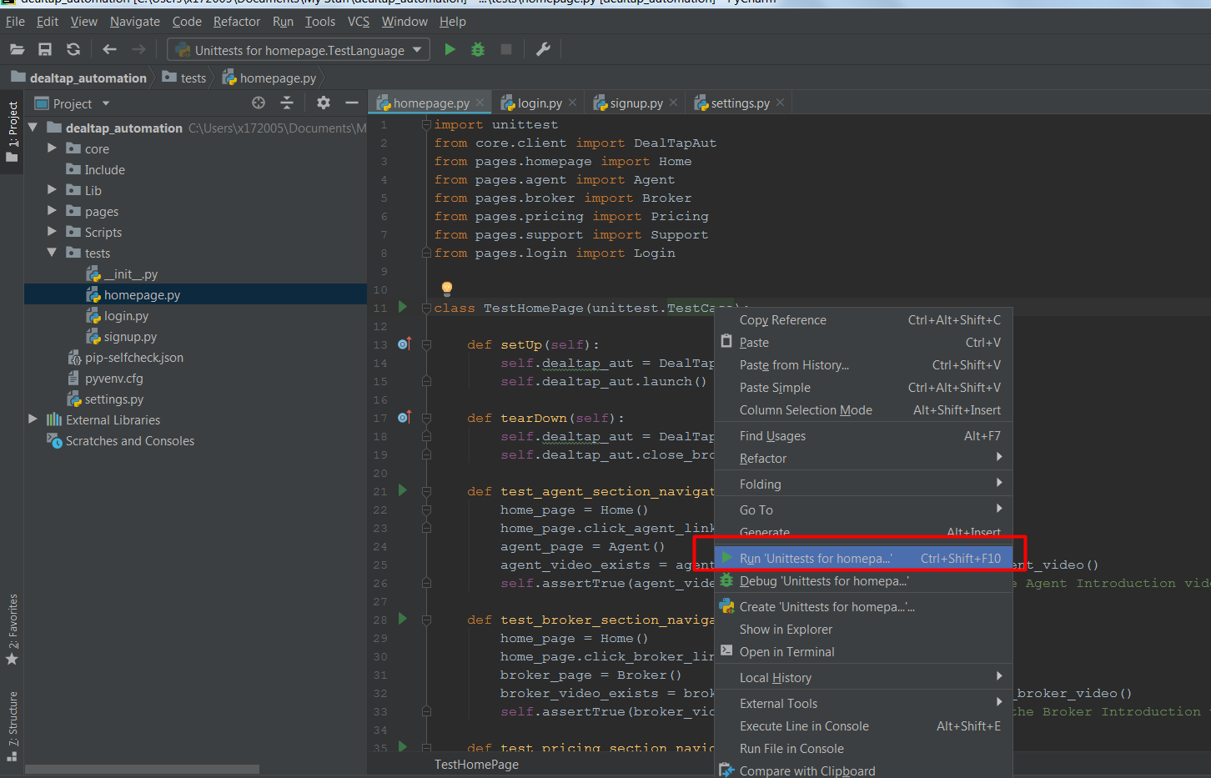

* Or tests can also be run via command line using the command: **python –m unittest tests.homepage.TestHomePageNavigation** by running the command from the root folder of the project (i.e. dealtap_automation folder)

## Test Strategy

For the purposes of this assignment our test strategy will solely focus on UI automation. In case certain tests cannot be automated using UI automation or are expensive to test at the UI layer we can choose to build another API testing framework for those suite of tests or run them manually if they cannot be covered via UI, API or even unit testing.

Once the automated tests are developed, we will hook our test suite to a continuous integration tool such as Jenkins to trigger the test run on latest release/dev builds as well as run them on demand.

The home page navbar allows users to navigate to certain key areas of the site that we are going to test:

* Home: <dealtap domain>
* Agent: <dealtap domain>/agent
* Broker: <dealtap domain>/broker
* Pricing: <dealtap domain>/pricing
* Support: <dealtap zendesk domain>

The two other main pages that can be reached via the navigation bar are the following pages:

* Home: <dealtap domain>/signup
* Agent: <dealtap domain>/login

The footer area of the home page contains links to the following:

* Home: <dealtap domain>
* Agent: <dealtap domain>/agent
* Broker: <dealtap domain>/broker
* Pricing: <dealtap domain>/pricing
* Support: <dealtap zendesk domain>
* Security: <dealtap domain>/security
* About Us: <dealtap domain>/about-us
* Careers: <dealtap domain>/careers
* Contact Us: <dealtap zendesk domain>/requests/new
* Blog: <medium domain>/dealtap
* Privacy: <dealtap domain>/privacy
* Legal: <dealtap domain>/legal
* Facebook page: <facebook domain>/dealtap
* LinkedIn page: <linkedin domain>/dealtap

For the purposes of this assignment we are going to skip testing the footer sections of the website.

Below is the table of tests steps that have been covered by automation for this assignment:

|  |  |  |
| --- | --- | --- |
| **Test Cases** | **Test Steps** | **Verification** |
| **Homepage Navigation** | | |
| Navigation to agent section from homepage | Go to home page  Click on navbar link for Agent | Agent Introduction video present |
| Navigation to broker section from homepage | Go to home page  Click on navbar link for Broker | Broker Introduction video present |
| Navigation to pricing section from homepage | Go to home page  Click on navbar link for Pricing | Pricing Page Header Intro text present |
| Navigation to support section from homepage | Go to home page  Click on navbar link for Support | Support Page Header Intro text present |
| Navigation back to home page from homepage | Go to home page  Click on navbar link for DealTap | DealTap Header Intro text present |
| Navigation to login page from homepage | Go to home page  Click on navbar link for Login | Login Page ‘Log into Account’ text present |
| **Login** | | |
| Test invalid email as username | Go to Login Page from home page  Input invalid email format | Ensure ‘Email is Invalid’ text is shown |
| Test failed login attempt | Go to Login Page from home page  Input invalid email and password | Ensure popup shows up with ‘Login failed. Incorrect username or password.’ Text |
| Test successful login attempt | Go to Login Page from home page  Input valid email and password | Ensure user is redirected to Dashboard – Home page for Agent. |
| **Sign Up** | | |
| Test valid signup for user | Go to sign up from home page  Follow steps for valid user sign up | Ensure ‘Your account was created successfully’ text shows up in activation page once sign up is complete |